HL7 FHIR Implementation Guide: electronic Long-Term Services and Supports (eLTSS), Release 1, US Realm

# HOME (tab)

## Implementation Guide Home Page

Table of Contents (link)

## Introduction

The eLTSS Implementation Guide (IG) is based on [FHIR Version R4](http://build.fhir.org/index.html) and defines the minimum conformance requirements for exchanging LTSS data between beneficiaries (patients), providers and care team members using non-clinical and clinical systems (e.g. EHR, PHR, HIE, case management systems, LTSS provider systems).

The eLTSS data referenced in this implementation guide refers to the eLTSS Dataset that was developed by the eLTSS Initiative, a joint project between the Office of the National Coordinator for Health Information Technology (ONC) and the Centers for Medicare and Medicaid Services (CMS). The eLTSS Dataset was input for the Informative Document titled “HL7 Cross-Paradigm Information Sharing for Electronic Long-Term Services & Supports (eLTSS), Release 1” balloted during the September 2018 cycle. This IG is further advancing the eLTSS dataset to FHIR mapping found in the Informative Document into FHIR-specific implementer guidance.

## Scope

The scope of this implementation guide is to describe how HCBS data requirements, documented in the 56 data elements included in the eLTSS Dataset, can be represented for exchange and sharing using FHIR.

The IG will use FHIR US Core R4 as a starting point and will profile the following resources as necessary to enable eLTSS Plan Creation and Exchange:

* CarePlan
* CareTeam
* Claim
* Condition
* Contract
* Coverage
* DocumentReference
* EpisodeOfCare
* Goal
* Location
* Observation
* Organization
* Patient
* Practitioner
* Questionnaire
* QuestionnaireResponse
* Related Person
* RiskAssesment
* ServiceRequest

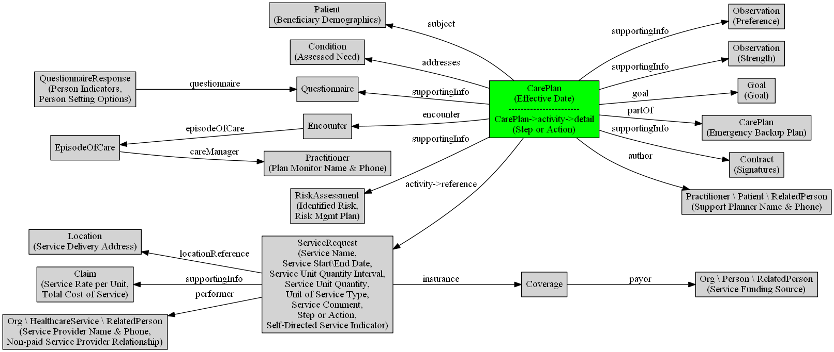

## US Core Dependency

Please note that implementations using this eLTSS FHIR IG must comply with US Core when applicable. US Core defines the minimum conformance requirements for accessing patient data as defined by the Argonaut pilot implementations and the ONC 2015 Edition Common Clinical Data Set (CCDS). These profiles are intended to be the foundation for US Realm FHIR implementation guides. Therefore, [US Core Profiles](http://hl7.org/fhir/us/core/2019Jan/profiles.html), [US Core Terminology](http://hl7.org/fhir/us/core/2019Jan/terminology.html), [US Core Capability Statements / Conformance Requirements](http://hl7.org/fhir/us/core/2019Jan/capstatements.html), and [Security Considerations](http://hl7.org/fhir/us/core/2019Jan/security.html) not specifically noted in this guide must be included when applicable.

## eLTSS Actors

The following actors are reused from US Core:

* [US Core Requestor](http://hl7.org/fhir/us/core/2019Jan/index.html#us-core-actors): An application that initiates a data access request to retrieve patient and service data. This can be thought of as the client in a client-server interaction.
* [US Core Responder](http://hl7.org/fhir/us/core/2019Jan/index.html#us-core-actors): A product that responds to the data access request providing patient and service data. This can be thought of as the server in a client-server interaction.

## eLTSS Example Scenarios

LTSS is currently document-oriented exchange paradigm (e.g., consumers exchange the entire service plan as a document), however during outreach stakeholders expressed an interest in the ability to exchange portions of service plan data, query specific elements, receive notifications, etc. The aim of eLTSS is to enable those exchanges and features for LTSS data.

The first scenario is to Use FHIR Resources to generate an eLTSS plan in an LTSS case management system. The minimal set of FHIR Resources needed to do this include: Bundle, CarePlan, CareTeam, Claim, Condition, Contract, Coverage, DocumentReference, EpisodeOfCare, Goal, Location, Observation, Organization, Patient, Practitioner, Questionnaire, QuestionnaireResponse, Related Person, RiskAssesment, ServiceRequest

Once an eLTSS plan is created using FHIR, we have identified 4 sample use cases to highlight the possible exchanges that an eLTSS Plan may be involved. The figure below illustrates the use cases. Read on for textual explanations of each use case.

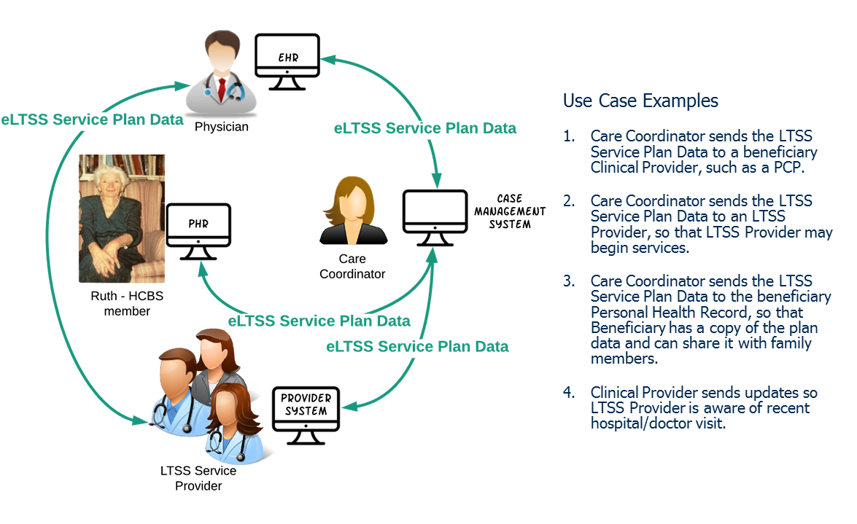

### 1.6.1 Exchange eLTSS Plan from Support Planner (case management system) to Clinical and Institutional-based Provider (EHR system)

* Purpose: The clinical and institutional-based provider is informed of what service(s) the Beneficiary is eligible for and to supply additional details around the services as well as the Beneficiary to enable better delivery of services and support.
* eLTSS Data: Clinical and Institutional-based Provider may need cost information (Claim), emergency backup plan (CarePlan), full details on service quantities (ServiceRequest), etc. Important information includes contact information for a financial management worker (Practitioner).

### 1.6.2 Exchange eLTSS Plan from Support Planner (case management system) to HCBS Provider (provider system)

* Purpose: To inform HCBS Provider of service(s) requested by Beneficiary, or are authorized for the Beneficiary, as well as to supply additional detail around those services and the Beneficiary to enable better delivery of services and supports.
* eLTSS Data: HCBS Providers need service and cost information (Units and Unit Costs, Effective Dates, etc.) (ServiceRequest, Claim), especially if there is a change (e.g., due to a re-assessment). This use case would be the vehicle to communicate these data elements to the HCBS Providers officially, even if the services (and quantity and rates) were previously negotiated. Signatures (Contract) are not required; however, the eLTSS Signature Date data elements (Contract) indicating when the plan was approved (CarePlan) could be important.

### 1.6.3 Exchange eLTSS Plan from Support Planner (case management system) to Beneficiary (PHR)

* Purpose: The Beneficiary has a complete record of what is either proposed or to be provided to them and by whom, and potentially be imported into the Beneficiary’s PHR.
* eLTSS Data: Beneficiary will not need signatures (Contract) and may not need cost information (Claim).

### 1.6.4 Exchange eLTSS Plan from HCBS Provider (provider system) to Clinical Provider (EHR) (vice versa)

* Purpose: The Clinical Provider is aware of the services the Beneficiary is receiving and what their goals/needs/risks are or have been. The HCBS Provider is aware of the Beneficiary's recent hospital/doctor visit and any discharge/treatment instructions to follow.

# 2. BACKGROUND (tab)

## 2.1 Project Background

The eLTSS Initiative is a joint CMS and ONC project initiated in 2014 as one of the four components of the Medicaid Testing Experience and Functional Tools (TEFT) demonstration grant program. It is facilitated through a public collaborative platform, the ONC Tech Lab—previously referred to as the Standards & Interoperability Framework—and includes participants from six TEFT-grantee states (Colorado, Connecticut, Georgia, Kentucky, Maryland and Minnesota), and the broader HCBS community to include service providers, advocates, consumer representatives and HCBS system vendors.

The primary objectives of the eLTSS Initiative are: 1) to identify components or data elements needed for the electronic creation and interoperable exchange of person-centered service plans by health care and HCBS providers, payers and the individuals they serve; and 2) to field test these data elements within participating organizations’ electronic systems.

Unlike previous Federal-led initiatives that focused on advancing health IT adoption and health information exchange between clinical and institutional settings, eLTSS is the first federal initiative that addresses the interoperability gap between HCBS providers, beneficiaries, and their caregivers and between HCBS providers and clinical providers. It is also unique in that it addresses information requirements for social determinants of health (SDOH) data such as housing, education, and transportation, each of which influence individuals’ ability to maintain their health.

The key artifact of interest for the HL7 Community is the eLTSS Dataset. The eLTSS Dataset was developed using a consensus-based approach where eLTSS participants determined the set of data elements commonly found on a service plan. The data elements were initially derived from the service plans each of the TEFT grantees are using within their respective states, most of which were paper-based. The data elements were consolidated, reviewed and harmonized into a smaller set through facilitated public sessions with the eLTSS ONC Tech Lab participants. The process described above culminated in the publication of a set of 56 common data elements, referred to as the eLTSS Dataset.

The Georgia Team (representatives from Department of Community Health (DCH) and Georgia Tech Research Institute (GTRI)) with assistance from ONC and CMS developed an Informative Document titled “HL7 Cross-Paradigm Information Sharing for Electronic Long-Term Services & Supports (eLTSS), Release 1” balloted during the September 2018 cycle. This Informative Document included detailed mappings of the eLTSS Dataset to HL7’s Standards of FHIR and C-CDA. This Implementation Guide is advancing the FHIR mapping from that artifact into an HL7 FHIR Implementation Guide.

Extensive documentation of the initiative process, interim documents produced, summaries of decisions made, and other detailed documentation are available on the ONC eLTSS wiki site.

## 2.2 eLTSS Project Purpose

Electronic Long-Term Services & Supports (eLTSS) aims to enable electronic data-level interoperability and exchange of data reflected on the person-centered service plans. The ultimate goal is to leverage HIT standards and electronic information sharing to improve the delivery and coordination of community-based care provided under programs such as Medicaid Waivers. This project is the continuation of work performed under the eLTSS Initiative, a joint effort by ONC and CMS, that published an eLTSS Dataset and balloted the “HL7 Cross-Paradigm White Paper: Electronic Long-Term Services & Supports (eLTSS), Release 1” in the Sep 2018 ballot cycle. Current HL7 Standards include content to enable the creation and exchange of medically-focused care plans. This effort aims to provide guidance to access and exchange community-based service information alongside the medical interventions for a comprehensive picture of a person’s care.

The adoption and use of Health IT and quality measurement for community-based long-term services and supports is limited. Limitations include:

* lack of uniformity in the terminology and definitions of data elements, including those important to the beneficiary, needed for assessments and service plans used across and between community-based information systems, clinical care systems and personal health record systems;
* insufficient business and/or financial incentives for service providers to acquire and use Health IT to support coordination of services;
* minimal national standards for quality measurement in LTSS outcomes;
* lack of consensus on the inter-relationships between a beneficiary’s plans across care, services and supports; and
* lack of evidence and understanding of how Health IT may benefit the beneficiary and encourage their adoption and use of Health IT.
* lack of established best practices for complying with legal security and privacy requirements when electronically exchanging data between covered clinical entities and non-clinical entities providing community-based services.

The eLTSS FHIR IG will help drive the discussion to begin to remove these limitations by providing an official compilation of all the FHIR-related artifacts and documentation needed to enable exchange of eLTSS Dataset via FHIR (e.g. eLTSS Dataset FHIR mappings, eLTSS data exchange scenarios, examples). The IG will be matured to a Standard for Trial Use (STU) and will serve to support continued testing activities and evaluation by implementers.

## 2.3 Authors and Contributors

|  |  |  |
| --- | --- | --- |
| **NAME** | **Role** | **Organization** |
| Amber Patel | Author | SRS |
| Anastasia Perchem | Contributor | Office of the National Coordinator for Health Information Technology |
| Becky Angeles | Author | Carradora Health, Inc. |
| Bonnie Young | Contributor | Georgia Department of Community Health |
| Elizabeth Palena Hall | Contributor | Office of the National Coordinator for Health Information Technology |
| Greg White | Author | SRS |
| Irina Connelly | Contributor | Georgia Tech Research Institute |
| Jack Wallace | Author | Georgia Tech Research Institute |
| Jamie Parker | Author | Carradora Health, Inc. |
| Johnathan Coleman | Author | SRS |
| Kerry Lida | Contributor | Centers for Medicare & Medicaid Services |
| Mark Meadows | Contributor | Georgia Department of Community Health |

# 3.0 PROFILES (tab)

## 3.1 eLTSS Profiles

The list of eLTSS Profiles is shown below. Each profile defines that minimum mandatory elements that MUST be present. For each profile requirements and guidance is given in a simple narrative summary. A formal hierarchical table that presents a logical view of the content in both a differential and snapshot view is provided.

NOTE: Lloyd recommended to create a Profile for each Resource to denote the eLTSS mapping for the Resource elements. I have only included 2 below – need to add in the other 16 or so…

* eLTSS Patient Profile: eLTSS Name=Person; eLTSS Description= The person whom the plan is for.
  + name 1..* (US Core)
    - family, given x2, text
    - eLTSS Name: Person Name
    - eLTSS Description: The name of the person whom the plan is for.
  + identifier 1..* (US Core)
    - eLTSS Name: Person Identifier
    - eLTSS Name: A string of characters used to identify the person whom the plan is for.
    - identifier.type [Extensible] = “MR” (Medical record number), “SB” (Social Beneficiary Number = State ID), ADD 45400-9 for Medicaid Number, ADD 45396-9 for Social Security Number, + text = “Other”
      * eLTSS Name: Person Identifier Type
      * eLTSS Description: The type of unique identifier used to identify the person whom the plan is for. Values include: Medicaid Number, State ID, Medical Record Number, Other (free text)
  + telecom.system = “phone”
  + telecom.value
    - eLTSS Name: Person Phone Number
    - eLTSS Description: The primary phone number of the person whom the plan is for, or his/her legal representative, where applicable.
  + birthDate
    - eLTSS Name: Person Date of Birth
    - eLTSS Description: The birth date of the person whom the plan is for.
  + address 0..*
    - line, city, state, postalCode, district, text
    - eLTSS Name: Person Address
    - eLTSS Description: The address of the person whom the plan is for. Street, City, State, Zip Code, County
  + contact.name
    - family, given x2, text
    - eLTSS Name: Emergency Contact Name
    - eLTSS Description: The name of the individual or entity identified to contact in case of emergency.
  + contact.relationship = “C”
  + contact.relationship [Extensible] = <http://www.hl7.org/implement/standards/fhir/valueset-relatedperson-relationshiptype.html>
    - eLTSS Name: Emergency Contact Relationship
    - eLTSS Description: The relationship (e.g., spouse, neighbor, guardian, daughter) of the individual identified to contact in case of emergency.
  + contact.telecom.system = “phone”
  + contact.telecom.value
    - eLTSS Name: Emergency Contact Phone Number
    - eLTSS Description: The primary phone number (and extension when applicable) of the individual or entity identified to contact in case of emergency.
* eLTSS CarePlan Profile: eLTSS Name: eLTSS Plan; eLTSS Description: Structured, longitudinal person-centered service plan that can be exchanged electronically across multiple community-based LTSS settings, institutional settings, and with beneficiaries and payers. The content or data elements of the eLTSS Plan is specific to the types of services rendered and information collected for CB-LTSS.

# 5.0 MAPPINGS (tab)

## 5.1 eLTSS Dataset Mapped to FHIR Resources and US Core Profiles

The table below lists the eLTSS Dataset Elements mapped to FHIR at the Resource level and US Core Profiles when applicable.

|  |  |  |
| --- | --- | --- |
| **eLTSS Dataset Element** | **FHIR Resource** | **US Core Profile** |
| Person Name | Patient | [US Core Patient Profile](http://hl7.org/fhir/us/core/StructureDefinition-us-core-patient.html) |
| Person Identifier | Patient | [US Core Patient Profile](http://hl7.org/fhir/us/core/StructureDefinition-us-core-patient.html) |
| Person Identifier Type | Patient | [US Core Patient Profile](http://hl7.org/fhir/us/core/StructureDefinition-us-core-patient.html) |
| Person Date of Birth | Patient | [US Core Patient Profile](http://hl7.org/fhir/us/core/StructureDefinition-us-core-patient.html) |
| Person Phone Number | Patient |  |
| Person Address | Patient |  |
| Emergency  Contact Name | Patient |  |
| Emergency  Contact Relationship | Patient |  |
| Emergency  Contact Phone Number | Patient |  |
| Emergency Backup Plan | CarePlan OR DocumentReference | [US Core CarePlan Profile](http://hl7.org/fhir/us/core/StructureDefinition-us-core-careplan.html) OR [US Core DocumentReference Profile](http://hl7.org/fhir/us/core/StructureDefinition-us-core-documentreference.html) |
| Goal | Goal | [US Core Goal Profile](http://hl7.org/fhir/us/core/StructureDefinition-us-core-goal.html) |
| Step or Action | CarePlan OR Service Request | [US Core CarePlan Profile](http://hl7.org/fhir/us/core/StructureDefinition-us-core-careplan.html) |
| Strength | Observation |  |
| Assessed Need | Condition | [US Core Condition Profile](http://hl7.org/fhir/us/core/StructureDefinition-us-core-condition.html) |
| Person Setting Choice Indicator | Questionnaire AND QuestionnaireResponse |  |
| Person Setting Choice Options | Questionnaire AND QuestionnaireResponse |  |
| Plan Monitor Name | Practitioner | [US Core Practitioner Profile](http://hl7.org/fhir/us/core/StructureDefinition-us-core-practitioner.html) |
| Plan Monitor Phone Number | Practitioner | [US Core Practitioner Profile](http://hl7.org/fhir/us/core/StructureDefinition-us-core-practitioner.html) |
| Preference | Observation |  |
| Service Options Given Indicator | Questionnaire AND QuestionnaireResponse |  |
| Service Selection Indicator | Questionnaire AND QuestionnaireResponse |  |
| Service Plan Agreement Indicator | Questionnaire AND QuestionnaireResponse |  |
| Service Provider Options Given Indicator | Questionnaire AND QuestionnaireResponse |  |
| Service Provider Selection Agreement Indicator | Questionnaire AND QuestionnaireResponse |  |
| Plan Effective Date | CarePlan | [US Core CarePlan Profile](http://hl7.org/fhir/us/core/StructureDefinition-us-core-careplan.html) |
| Person Signature | Contract |  |
| Person Printed Name | Contract |  |
| Person Signature Date | Contract |  |
| Guardian / Legal Representative Signature | Contract |  |
| Guardian / Legal Representative Printed Name | Contract |  |
| Guardian / Legal Representative Signature Date | Contract |  |
| Support Planner Signature | Contract |  |
| Support Planner Printed Name | Contract |  |
| Support Planner Signature Date | Contract |  |
| Service Provider Signature | Contract |  |
| Service Provider Printed Name | Contract |  |
| Service Provider Signature Date | Contract |  |
| Identified Risk | RiskAssessment |  |
| Risk Management Plan | RiskAssessment OR DocumentReference | [US Core DocumentReference Profile](http://hl7.org/fhir/us/core/StructureDefinition-us-core-documentreference.html) |
| Service Name | ServiceRequest |  |
| Self-Directed Service Indicator | ServiceRequest |  |
| Service Start Date | ServiceRequest |  |
| Service End Date | ServiceRequest |  |
| Service Delivery Address | Location | [US Core Location Profile](http://hl7.org/fhir/us/core/StructureDefinition-us-core-location.html) |
| Service Comment | ServiceRequest |  |
| Service Funding Source | Coverage |  |
| Service Unit Quantity | ServiceRequest |  |
| Unit of Service Type | ServiceRequest |  |
| Service Unit Quantity Interval | ServiceRequest |  |
| Service Rate per Unit | Claim |  |
| Total Cost of Service | Claim |  |
| Support Planner Name | Practitioner | CareTeam | Organization | Patient | |RelatedPerson | [US Core Practitioner Profile](http://hl7.org/fhir/us/core/StructureDefinition-us-core-practitioner.html)  [US Core CareTeam Profile](http://hl7.org/fhir/us/core/StructureDefinition-us-core-careteam.html)  [US Core Organization Profile](http://hl7.org/fhir/us/core/StructureDefinition-us-core-organization.html)  [US Core Patient Profile](http://hl7.org/fhir/us/core/StructureDefinition-us-core-patient.html) |
| Support Planner Phone Number | Practitioner | CareTeam | Organization | Patient | |RelatedPerson | [US Core Practitioner Profile](http://hl7.org/fhir/us/core/StructureDefinition-us-core-practitioner.html)  [US Core CareTeam Profile](http://hl7.org/fhir/us/core/StructureDefinition-us-core-careteam.html)  [US Core Organization Profile](http://hl7.org/fhir/us/core/StructureDefinition-us-core-organization.html)  [US Core Patient Profile](http://hl7.org/fhir/us/core/StructureDefinition-us-core-patient.html) |
| Service Provider Name | Practitioner | CareTeam | Organization | Patient | |RelatedPerson | [US Core Practitioner Profile](http://hl7.org/fhir/us/core/StructureDefinition-us-core-practitioner.html)  [US Core CareTeam Profile](http://hl7.org/fhir/us/core/StructureDefinition-us-core-careteam.html)  [US Core Organization Profile](http://hl7.org/fhir/us/core/StructureDefinition-us-core-organization.html)  [US Core Patient Profile](http://hl7.org/fhir/us/core/StructureDefinition-us-core-patient.html) |
| Service Provider Phone Number | Practitioner | CareTeam | Organization | Patient | |RelatedPerson | [US Core Practitioner Profile](http://hl7.org/fhir/us/core/StructureDefinition-us-core-practitioner.html)  [US Core CareTeam Profile](http://hl7.org/fhir/us/core/StructureDefinition-us-core-careteam.html)  [US Core Organization Profile](http://hl7.org/fhir/us/core/StructureDefinition-us-core-organization.html)  [US Core Patient Profile](http://hl7.org/fhir/us/core/StructureDefinition-us-core-patient.html) |
| Non-Paid Service Provider Relationship | RelatedPerson |  |

## 5.2 Detailed eLTSS Dataset to FHIR R4 Mapping

HTML Rendering of spreadsheet….

Link to spreadsheet. Where should the spreadsheet live?

# 6.0 CAPABILITY STATEMENTS (tab)

Not sure if we should include this. Or, should we put effort into a Search Parameters tab?

## 6.1 Capability Statements

• [US Core Server](https://build.fhir.org/ig/HL7/US-Core-R4/CapabilityStatement-us-core-r4-server.html) UsCoreServer

• [US Core Client](https://build.fhir.org/ig/HL7/US-Core-R4/CapabilityStatement-us-core-r4-client.html) UsCoreClient

# 7.0 TERMINOLOGY (tab)

## 7.1 Value Sets

These value sets are included in this implementation guide and are either required by eLTSS, FHIR or US Core.

| **eLTSS Dataset Element** | **FHIR Resource** | **Resource element** | **Requirement** | **Value Set** | **Possible Values** |
| --- | --- | --- | --- | --- | --- |
|  | CarePlan | CarePlan.status | FHIR and US CORE | [RequestStatus](http://hl7.org/fhir/valueset-request-status.html) | draft, active, suspended, completed, entered-in-error, cancelled, and unknown |
|  | CarePlan | CarePlan.intent | FHIR and US CORE | [CarePlanIntent](http://hl7.org/fhir/valueset-care-plan-intent.html) | proposal, plan, order, and option |
|  | CarePlan | CarePlan.text.status | Text is required by US Core, status is required by FHIR | [NarrativeStatus](http://hl7.org/fhir/us/core/2019Jan/ValueSet-us-core-narrative-status.html) | additional, generated |
|  | CarePlan | CarePlan.category | US Core: Must have a category of 'assess-plan' and a code system: http://hl7.org/fhir/us/core/CodeSystem/careplan-category | [CarePlanCategory](http://hl7.org/fhir/STU3/valueset-care-plan-category.html) | assess-plan |
|  | CarePlan | CarePlan.activity.detail.status | FHIR | [CarePlanActivityStatus](http://hl7.org/fhir/valueset-care-plan-activity-status.html) | not-started, scheduled, in-progress, on-hold, completed, cancelled, stopped, unknown, and entered-in-error. |
|  | CareTeam | CareTeam.status | US Core | [CareTeamStatus](http://hl7.org/fhir/STU3/valueset-care-team-status.html) | proposed, active, suspended, inactive, and entered-in-error |
|  | CareTeam | CareTeam.participant.role | US Core | [CareTeam Provider Roles](http://hl7.org/fhir/us/core/ValueSet-us-core-careteam-provider-roles.html) | Provider roles codes consist of NUCC Health Care Provider Taxonomy Code Set for providers and SNOMED-CT for - non clinical and organization roles including codes from the SCTID 125676002 Person (person) hierarchy and the SCTID 394730007 Healthcare related organization (qualifier value) hierarchy. |
|  | Condition | Condition.verificationStatus | US Core | [ConditionVerificationStatus](http://hl7.org/fhir/STU3/valueset-condition-ver-status.html) | provisional, differential, confirmed, refuted, entered-in-error, and unknown. |
|  | Condition | Condition.clinicalStatus | US Core: required by US Core if the value of ***verificationStatus*** is not "entered-in-error". | [Condition Clinical Status Codes](http://hl7.org/fhir/STU3/valueset-condition-clinical.html) | active, recurrence, inactive, remission, and resolved. |
|  | DocumentReference | DocumentReference.status | FHIR | [DocumentReferenceStatus](http://hl7.org/fhir/ValueSet-document-reference-status.html) | current, superseded, and entered-in-error. |
|  | DocumentReference | DocumentReference.type | US Core | [Document Type Value Set](http://hl7.org/fhir/STU3/valueset-c80-doc-typecodes.html) | Long list of LOINC codes |
|  | EpisodeOfCare | EpisodeOfCare.status | FHIR | [EpisodeOfCareStatus](http://build.fhir.org/valueset-episode-of-care-status.html) | planned, waitlist, active, onhold, finished, and cancelled |
|  | Goal | Goal.lifecycleStatus | US Core and FHIR | [GoalLifecycleStatus](http://build.fhir.org/valueset-goal-status.html) | proposed, planned, accepted, active, on-hold, completed, cancelled, entered-in-error, rejected |
|  | Observation | Observation.status | FHIR | [ObservationStatus](http://build.fhir.org/valueset-observation-status.html) | final, preliminary, registered, cancelled, amended, corrected, entered-in-error, and unknown |
| Emergency Contact Relationship | Patient | Patient.contact.relationship | eLTSS | [PatientContactRelationship](http://hl7.org/fhir/ValueSet/patient-contactrelationship) |  |
|  | Patient | Patient.gender | US Core | [AdministrativeGender](http://build.fhir.org/valueset-administrative-gender.html) | male, female, other, and unknown |
| Person Identifier Type | Patient | *Patient.identifier.type* | eLTSS | eLTSS Values include: Medicaid Number, State ID, Medical Record Number, Other (free text) | eLTSS to FHIR mapping (http://build.fhir.org/v2/0203/index.html): Medicaid Number = MA, State ID = SB, Medical Record Number = MR, Other (free text) = Patient.identifier.type.text |
|  | QuestionnaireResponse | QuestionnaireResponse.status | FHIR | [QuestionnaireResponseStatus](http://build.fhir.org/valueset-questionnaire-answers-status.html) | in-progress, completed, amended, entered-in-error, stopped |
|  | Questionnaire | Questionnaire.status | FHIR | [PublicationStatus](http://build.fhir.org/valueset-publication-status.html) | draft, active, retired, and unknown |
| Non-Paid Service Provider Relationship | Related Person | RelatedPerson.relationship | eLTSS | [PatientRelationshipType](https://www.hl7.org/fhir/valueset-relatedperson-relationshiptype.html) |  |
|  | RiskAssessment | RiskAssessment.status | FHIR | [ObservationStatus](http://build.fhir.org/valueset-observation-status.html) | registered, preliminary, final, amended, corrected, cancelled, entered-in-error and unknown. |
| Service Name | ServiceRequest | ServiceRequest.code.coding.system | eLTSS (recommended) | [HCPCS](https://www.cms.gov/Medicare/Coding/MedHCPCSGenInfo/) ,  [Home Health Revenue Codes](https://www.cgsmedicare.com/hhh/education/materials/pdf/home_health_billing_codes.pdf) |  |
| Self-Directed Service Indicator | ServiceRequest | ServiceRequest.extension.url | eLTSS | [Procedure-directedBy](http://build.fhir.org/extension-procedure-directedby.html) | Patient |
| Unit of Service Type | ServiceRequest | ServiceRequest.quantityQuantity.unit | eLTSS |  | eLTSS Values include: minute(s), 8 hour(s), quarter hour(s), hour(s), half day(s), full day(s), day(s), week(s), month(s), dollar(s), meal(s), mile(s), visit(s)/session(s), installation(s), none, other (free text). |
| ServiceRequest | ServiceRequest.quantityRatio.numerator.unit  ServiceRequest.quantityRatio.denominator.unit |
| Service Unit Quantity Interval | ServiceRequest | ServiceRequest.quantityQuantity.unit | eLTSS |  | eLTSS Values include: per day, per week, per month, per year, one time only, other (free text). |
|  | ServiceRequest | ServiceRequest.quantityRatio.numerator.unit  ServiceRequest.quantityRatio.denominator.unit | FHIR | [RequestIntent](http://build.fhir.org/valueset-request-intent.html) | proposal, plan, order, original-order, reflex-order, filler-order, instance-order and option |
|  | ServiceRequest | ServiceRequest.status | FHIR | [RequestStatus](http://build.fhir.org/valueset-request-status.html) | draft, active, suspended, completed, entered-in-error, and cancelled |